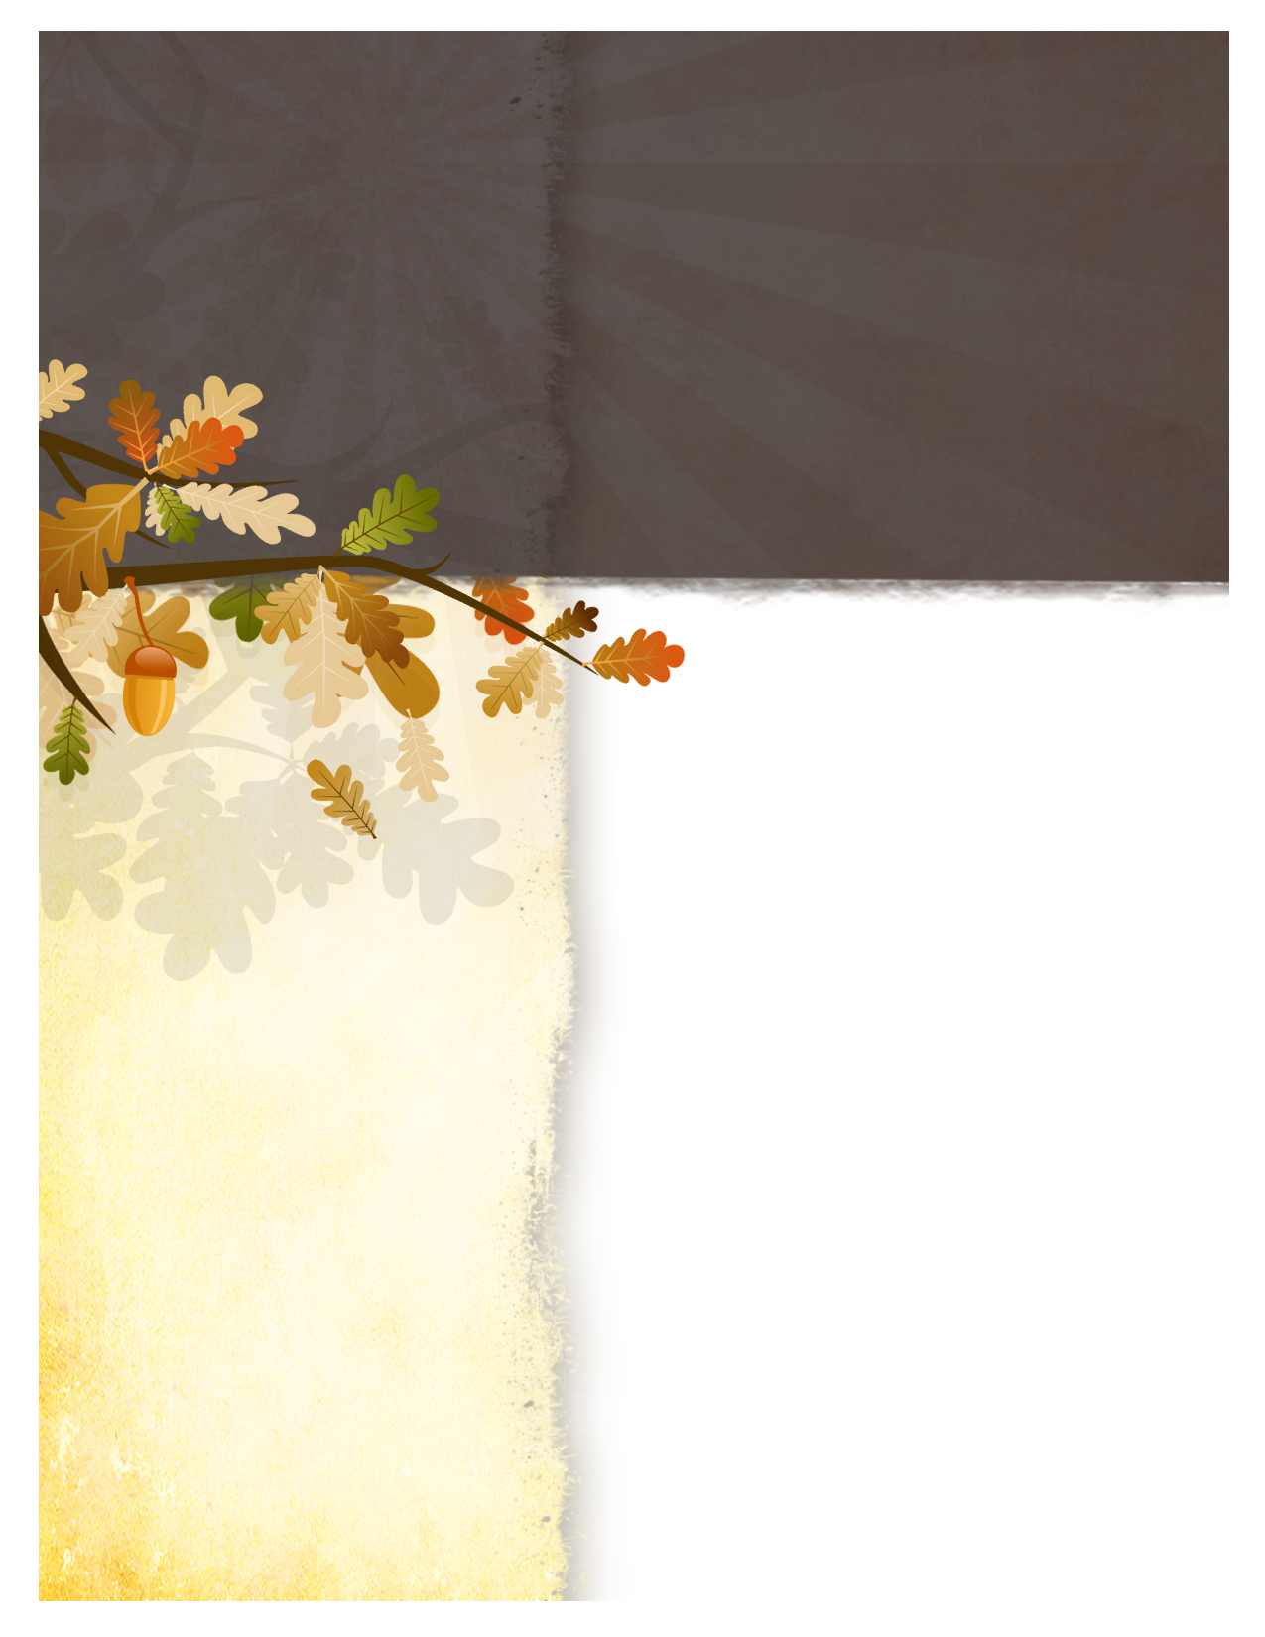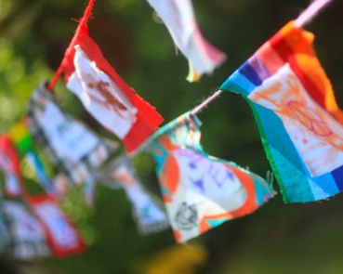

***+ Outdoor Worship and Picnic +***

***14Christ is our peace. He made both Jews and Gentiles into one group. With his body, he broke down the barrier of hatred that divided us. 15He canceled the detailed rules of the Law so that he could create one new person out of the two groups, making peace. 16He reconciled them both as one body to God by the cross, which ended the hostility to God. Ephesians 2: 14-16***

**We have been blessed every summer to hold our outdoor service at the Ojibwa Campground near the lighthouse on the beach. The beautiful setting of God’s good creation offers a harmonious tone to our worship service. This year’s theme was ‘Peace’ – the peace of Christ within us; peace with each other, peace in our community, and peace among the nations.**

**As a visual reminder of Christ breaking down the barrier of hatred that divides us, we made peace flags. The freedom of creativity flowed from the fabric markers onto the multi-colored squares. Eight year old Aden’s idea of peace was a picture of his two dogs facing each other with big smiles on their faces. Way to cute! His flag, along with all of yours, will be strung through a rope to hang outside the church entrance.**

**A BIG thank you to Bill and Cindy Giddings for the amazing grilled chicken, Mark Misegan at the Ojibwa Campground, and all of you for your presence, good food, and family fellowship!**

###### WELCA MEETINGS

**Tuesday, September 18th @ 11:00 am**

**Tuesday, October 16th @ 11:00 am**

**On the 3rd Tuesday of each month the ladies of Holy Cross hold a general meeting ~ a time for fellowship and activities.**

**New friends are welcome ~**

**Quilting**

On Tuesday mornings at 10:00 am at Holy Cross the ladies get together for quilting.

You do not need to be an experienced sewer to come and help out! There are many steps to makinga quiltand your talents will be used and greatly appreciated!

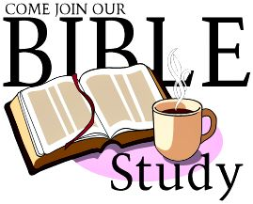

***Making Sense of Scripture***

***Bible Study at the Parsonage***

**Wednesday, September 19th 6:00 pm**

**Wednesday, October 17th 6:00 pm**

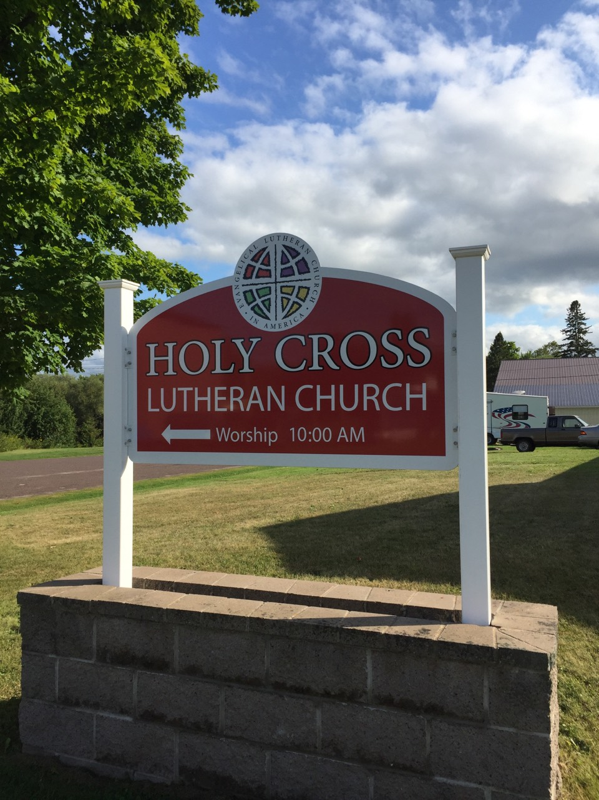

**New signs!**

Two new signs were designed and installed by Joe from Homestead Graphics. Very happy with the new look and bright color!

**Winter Clothing Giveaway**

**Saturday, October 20 from 10:00 am – Noon**

***If you or someone you know is in need of a warm jacket or winter clothing come to Holy Cross and see if we have something for you! Gladly accepting donations of new or gently used winter apparel of all sizes!***

***Coats, jackets, snow pants, hats, gloves and mittens, sweaters, boots, socks - anything to help someone stay warm this winter! Items can be dropped off at Holy Cross on Sundays or at the parsonage on Wednesdays and Thursdays - also Wilkinson's Store. Thanks for your support in this Outreach Event!***