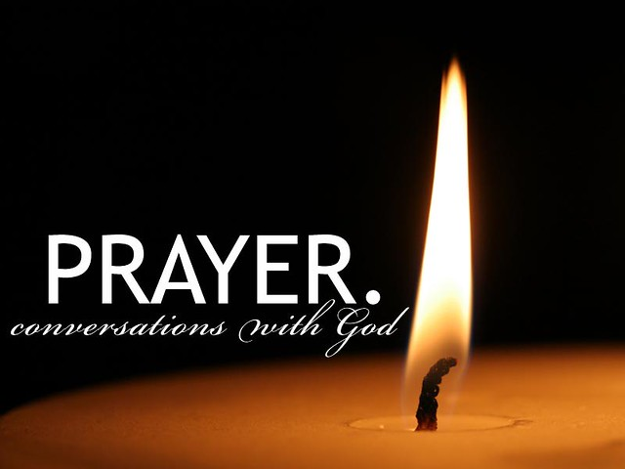
Prayers of Intercession for Sunday, June 7th

Called into unity with one another and the whole creation, let us pray for our shared world.

God of community, you form us as your church. Guide our bishops, pastors, deacons, and all the baptized in sharing your life-giving good news with all the world. Strengthen us to be bold in our proclamation. Hear us, O God, your mercy is great.
God of creation, you called everything into being. Sustain this world with your renewing care. Inspire us to see waterways, plant life, birds, fish, insects, and mammals and call them good. Hear us, O God, your mercy is great.
God of counsel, all authority belongs to you. Encourage the leaders of this and every land to seek peace, equality, and unity. Instill wisdom in advocates who work toward justice in often ignored communities. Hear us, O God, your mercy is great.
God of care you created us in your image. Help us see your likeness in one another. Open our eyes to see and attend to all who face oppression and suffering. Console, heal, and nourish all in need. Hear us, O God, your mercy is great.
God of companionship, you accompany this body of faith. As the rhythms of summer begin, protect all who travel, renew all who will enjoy a time of Sabbath, and shelter all who will not be protected from the sun’s heat. Hear us, O God, your mercy is great.
God of compassion, you comfort us in our grief with the promise of the resurrection. We give you thanks for the saints of all time and in our lives. Hear us, O God, your mercy is great.
Receive these prayers, O God, and those too deep for words; through Jesus Christ our Lord. Amen.

